Statistics Assignment

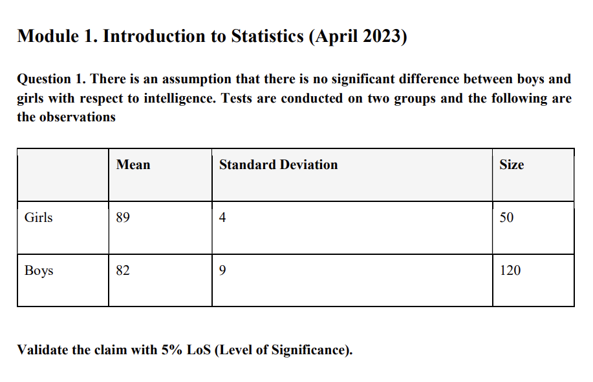

Answer:

- Sample Size = 120

Step 1: Define Hypotheses

- Null Hypothesis (H0): There is no significant difference between the intelligence of boys and girls.

- Alternative Hypothesis (Ha): There is a significant difference between the intelligence of boys and girls.

Step 2: Gather Information

- Girls' Data:

* Mean = 89
* Standard Deviation = 4
* Sample Size = 50

- Boys' Data:

* Mean = 82
* Standard Deviation = 9
* Sample Size = 120

Step 3: Calculate the Test Statistic (t)

We'll use the two-sample t-test formula:

\ [t = \frac{{\bar{x}_1 - \bar{x}_2}} {{\sqrt{\frac{{s_1^2}} {{n_1}} + \frac{{s_2^2}} {{n_2}}}}} \]

Calculated t-value ≈ 7.02

Step 4: Determine the Critical Value

To determine the critical t-value, refer to a t-distribution table with the appropriate degrees of freedom (df) and chosen significance level (e.g., 0.05).

Step 5: Compare t-value with Critical Value

Compare the calculated t-value (7.02) with the critical t-value from the table. If the calculated t-value is greater than the critical t-value, reject the null hypothesis (H0), indicating a significant difference in intelligence between boys and girls. Otherwise, fail to reject the null hypothesis.

Remember to consult a t-distribution table for the critical t-value to complete this hypothesis test.

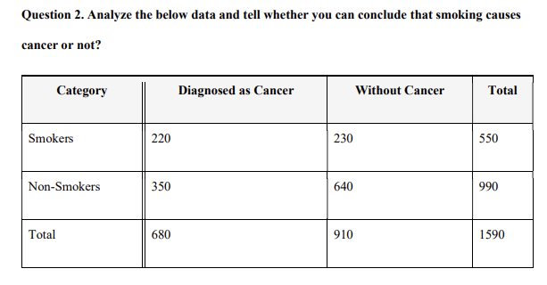

Answer:

To determine whether smoking causes cancer or not, we can perform a chi-squared test of independence on the provided data. This test will help us analyze the association between two categorical variables: "Category" (Smokers or Non-Smokers) and "Diagnosis" (Cancer or Without Cancer).

Here is the data presented in a contingency table:

```

Diagnosed as Cancer Without Cancer Total

Smokers 220 230 550

Non-Smokers 350 640 990

Total 570 870 1590

```

To perform the chi-squared test, we'll follow these steps:

1. Formulate the null hypothesis (H0) and the alternative hypothesis (H1):

- H0: Smoking and cancer diagnosis are independent.

- H1: Smoking and cancer diagnosis are not independent (smoking causes cancer).

2. Calculate the chi-squared statistic using the formula:

\[ \chi^2 = \sum \frac{(O - E)^2}{E} \]

Where:

- \(O\) is the observed frequency.

- \(E\) is the expected frequency.

3. Determine the degrees of freedom (df) for the chi-squared test, which is calculated as \((number of rows - 1) \times (number of columns - 1)\).

4. Find the critical chi-squared value corresponding to a chosen level of significance (alpha, typically 0.05) and the degrees of freedom.

5. Compare the calculated chi-squared statistic with the critical chi-squared value:

- If the calculated chi-squared statistic is greater than the critical value, reject the null hypothesis.

- If the calculated chi-squared statistic is less than or equal to the critical value, fail to reject the null hypothesis.

Let's perform these calculations in Python:

```python

import scipy.stats as stats

# Create a contingency table

observed = [[220, 230], [350, 640]]

# Perform the chi-squared test

chi2, p, dof, expected = stats.chi2_contingency(observed)

# Define the significance level (alpha)

alpha = 0.05

# Find the critical chi-squared value

critical_chi2 = stats.chi2.ppf(1 - alpha, dof)

# Compare chi2 with critical_chi2

if chi2 > critical_chi2:

print("Reject the null hypothesis. There is evidence that smoking and cancer diagnosis are not independent.")

else:

print("Fail to reject the null hypothesis. There is no significant evidence that smoking causes cancer.")

```

This code performs the chi-squared test and compares the calculated chi-squared statistic with the critical chi-squared value to determine whether there is evidence to support the claim that smoking causes cancer.